**Lombok:**

<https://www.baeldung.com/intro-to-project-lombok>

https://projectlombok.org/

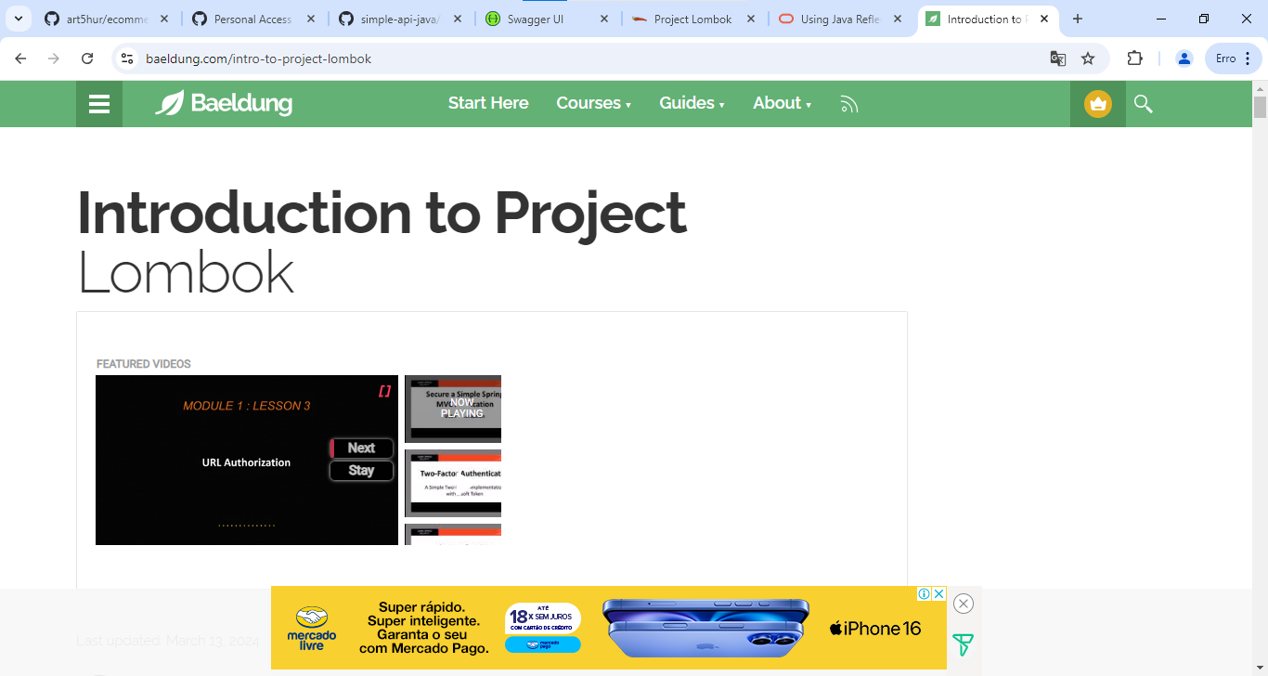

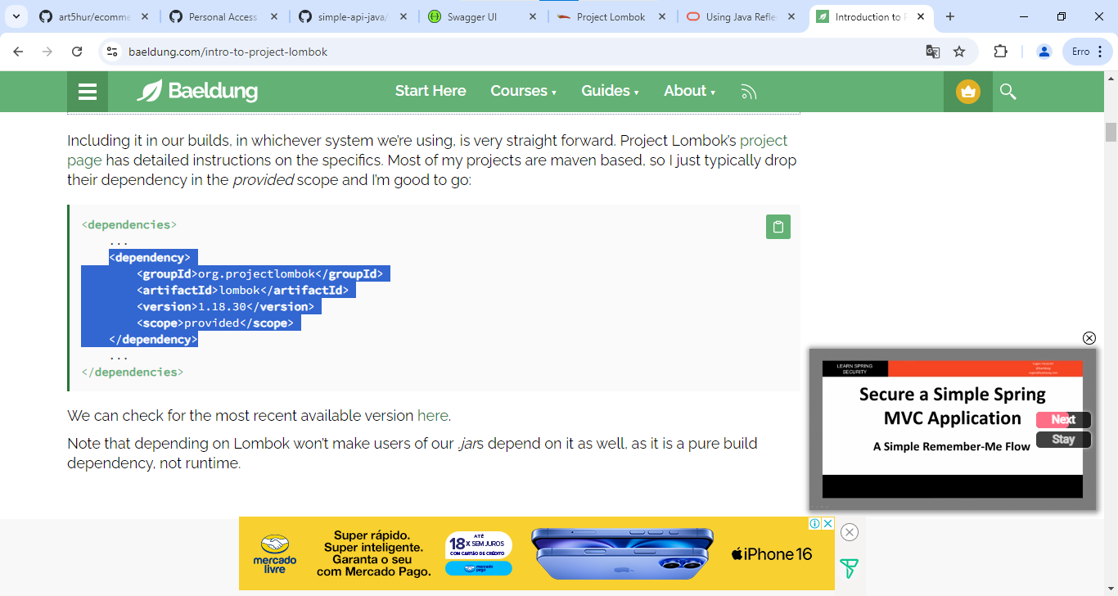

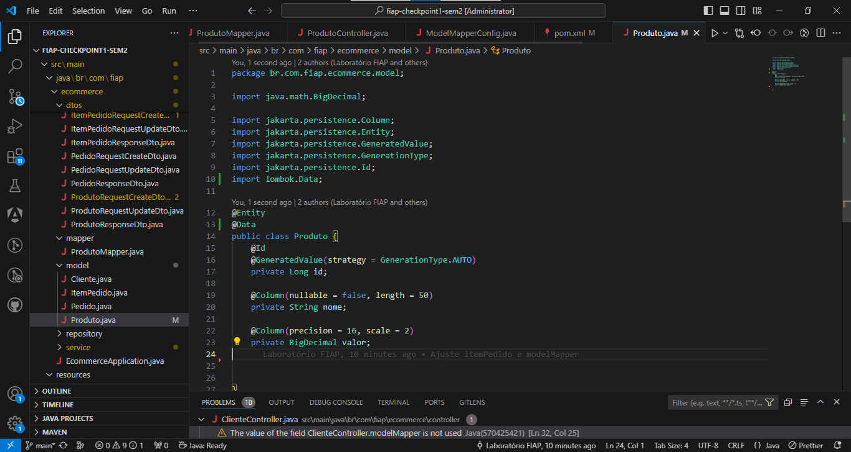

11/10/2024

**Projections:**

**https://www.baeldung.com/spring-data-jpa-projections**

<?> - quando não se sabe o retorno da classe

